Once upon a time, in a small village nestled in the mountains, there lived a young

girl named Lily. She was known throughout the village for her kind heart and

adventurous spirit. One day, while exploring the forest, she stumbled upon a

hidden cave and inside, she found a magical amulet that granted her the power to

talk to animals.

Lily was born on November 22, 1990.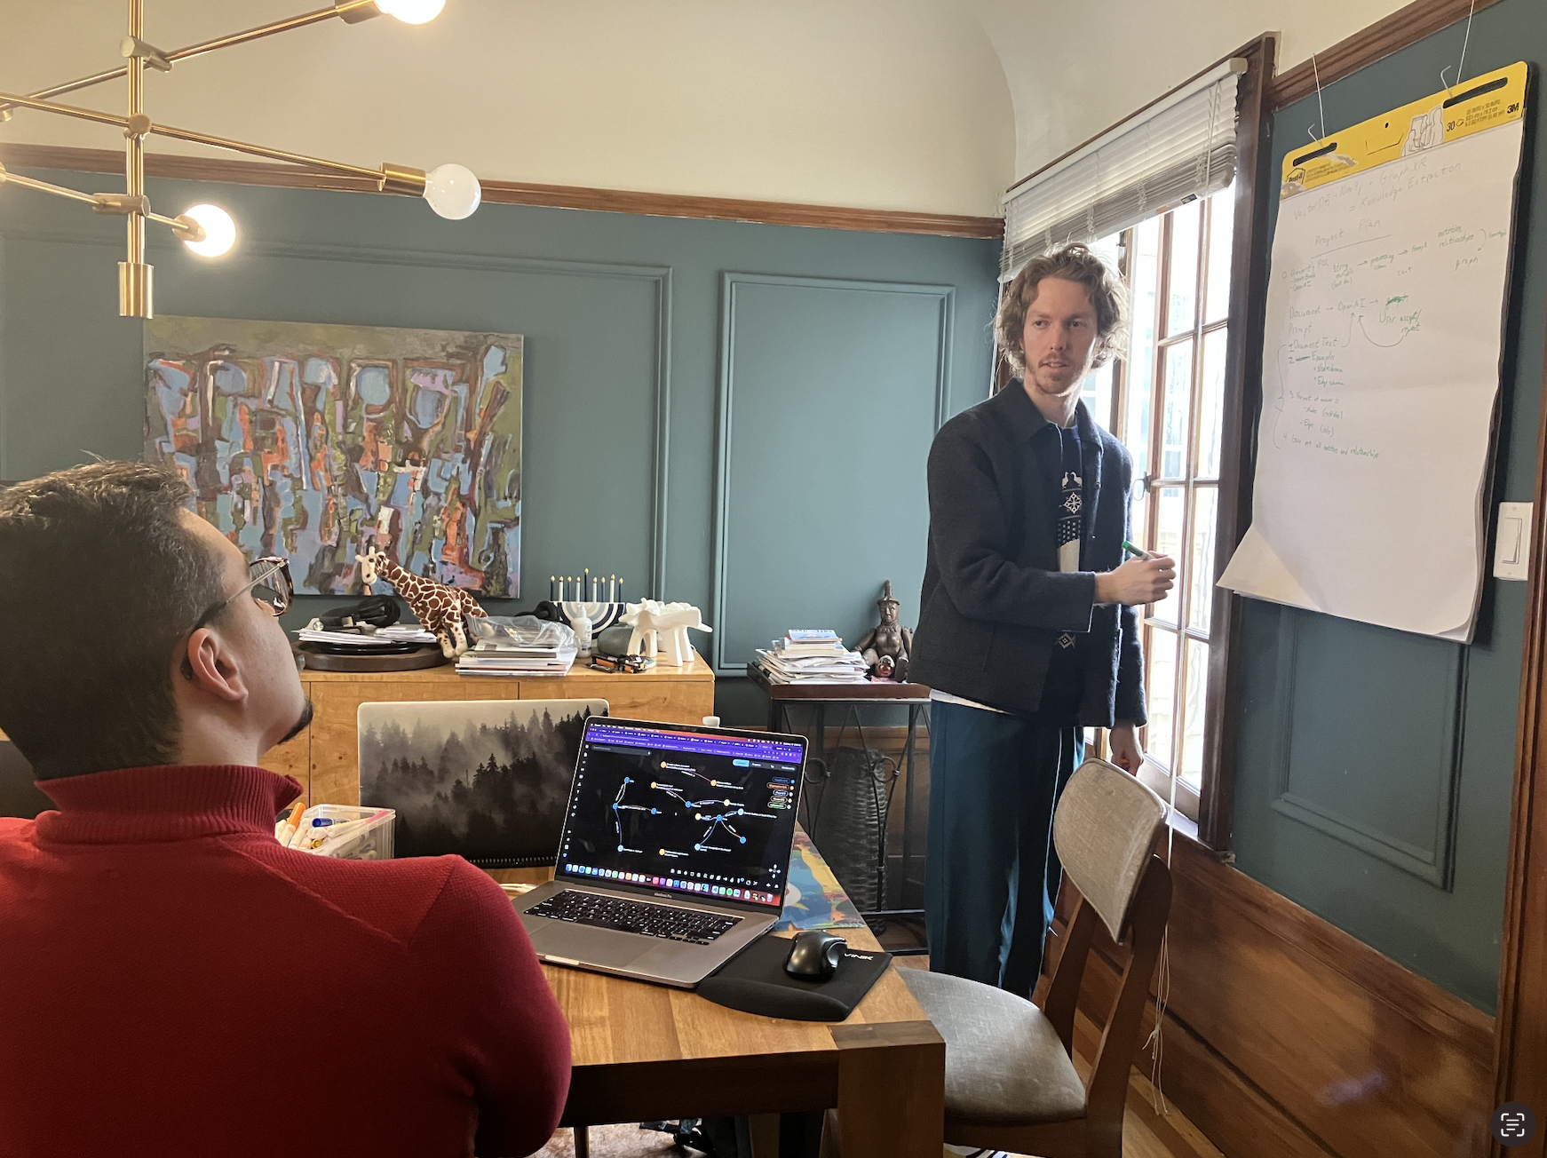

Excited by her newfound ability, Lily spent her days conversing with the creatures

of the forest and helping them with their problems. She became beloved by all the

animals and soon, word of her magical powers spread throughout the village. People

came from far and wide to seek her help and she became known as the protector of

the forest. From that day on, Lily lived a life filled with adventure and wonder,

always surrounded by the creatures she loved and protected.